Test 03 Tutorial

We will be creating a pan and zoom effect, let's start with the pan.
The way Flash works is that it doesn't actually have a 3D camera to speak of, instead we'll simulate some camera moves by re-positioning the entire scene over time and shift it or scale it across the timeline as the viewfinder (red border) stays locked in position.

1) Place a keyframe (F6) on frame 9 of the BG layer. This is where your camera move will begin (but don't move the scene at this point). This is the point of origin, not the destination, so don't move this first key.

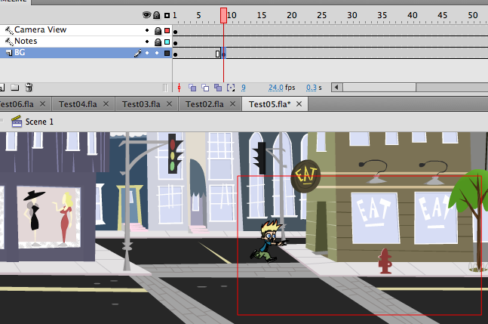

2) Now place another keyframe (F6) on frame 53. This is where we'll have the camera stop because the action stops here too. Click on the scene itself, hold down the SHIFT key and press the LEFT arrow key to shift the art over to center it in the red viewfinder.

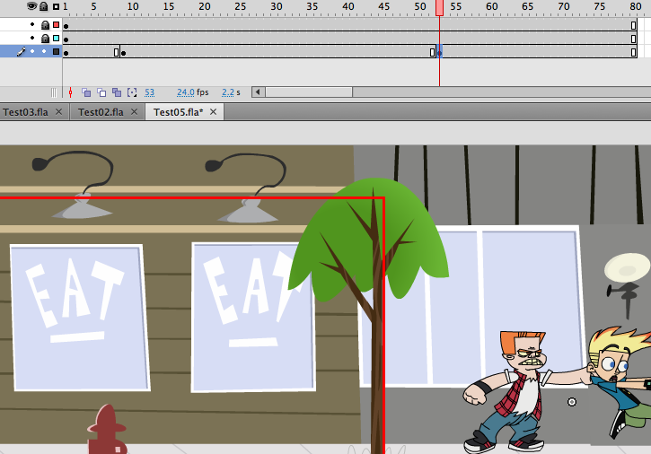

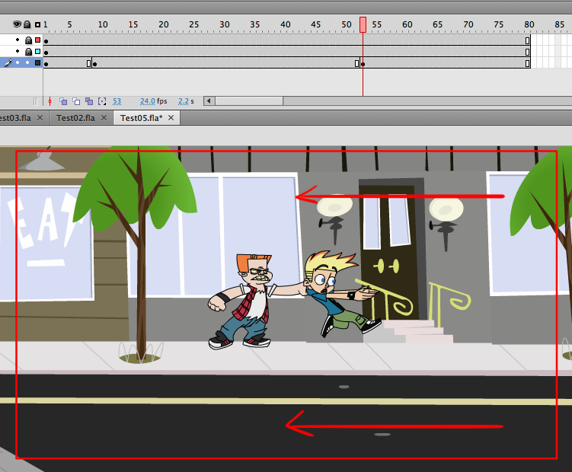

3) Right click on frame 9, and select Create Classic Tween. Always use Classic Tween, never, never, never use Motion Tween.

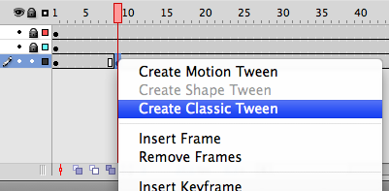

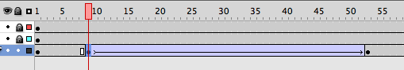4) Now to prevent from the camera from appearing to start too abruptly, click on the first keyframe you made on frame 9. Go to your PROPERTIES window to the far right and click on the small pencil icon in the TWEENING section. This opens up a graph editor window to customize the acceleration of the camera pan.

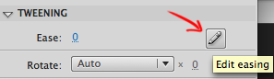

Adjust the bottom left little black square dot by clicking on it, a small circle will appear, grab it and pull down the handle al the way down and a bit to the left to make a bend in the line. Then click on the far right tiny black square dot in the top corner, and adjust the handle to create a straight line for the whole top right half of the diagonal line. Click OK.

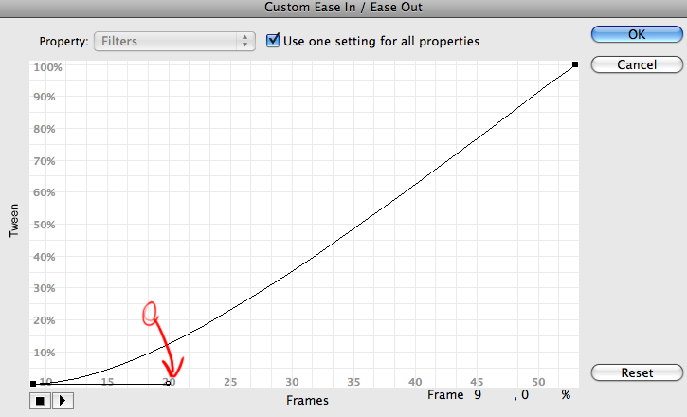

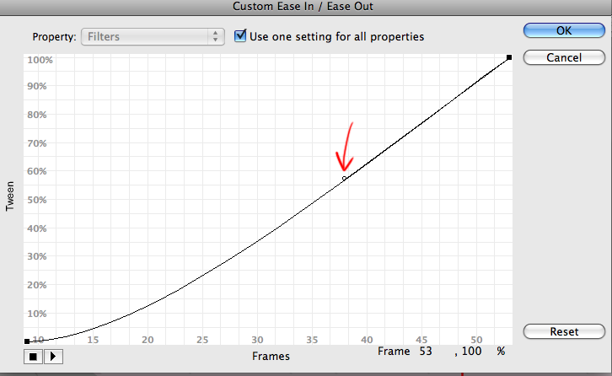

5) Now let's simulate the 'cameraman' actually overshooting the position of the character and quickly coming back to readjust the framing.

We do this by clicking on frame 57, and press F6 (to insert a keyframe).
Then go back to frame 53, click on the keyframe, then go down and click on the scene itself to select it, hold down the SHIFT key and press the LEFT arrow key to move over the art over just a bit to off-center it.

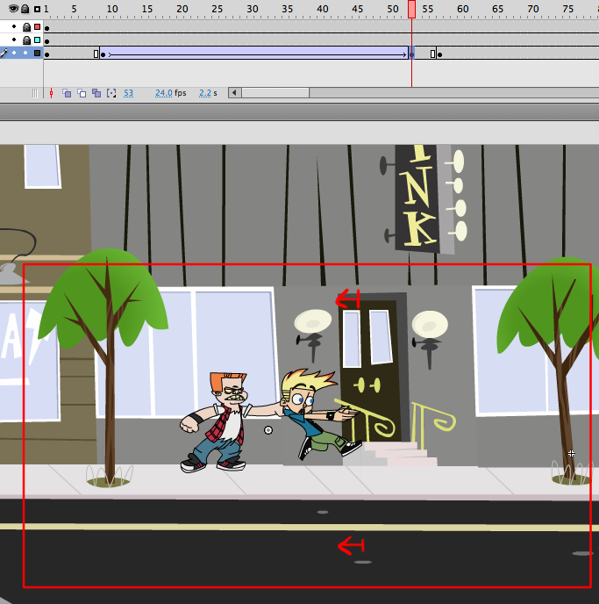

6) Right click on frame 53 and choose Classic Tween. Then go to the Tweening section on the right and click on the Ease: 0 number, and drag it to the right to ease out to anywhere between 70 or 80.

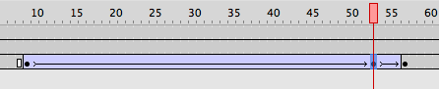

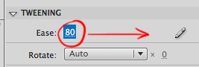

If you scroll your red line cursor to the beginning of the timeline and hit Enter, you'll see the camera move by motioning the scene through the viewfinder, tracking on the running character, then abruptly changing direction to focus on the suddenly stopped kid grabbed by the bully.

7) Now to add a slight pause then a quick zoom-in with a camera bounce to add a nice cartoony effect on the scene.

Click on frame 67, add a keyframe (F6).
Go to frame 78, add a keyframe (F6).
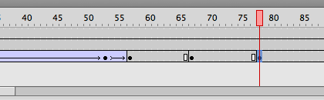

Click on the Magnifying Glass Icon in your tool bar on the far left, (this is your zoom in and out device), hold down the ALT key and click on the scene to zoom out a bit.

8) Go up towards the top left of the screen and click on the Free Transform tool from your tool bar.

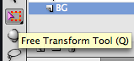

Click on the scene itself and you'll see it now has tiny black boxes in the corners.
Click and drag the top right corner of the entire scene (while holding down SHIFT) to enlarge it.

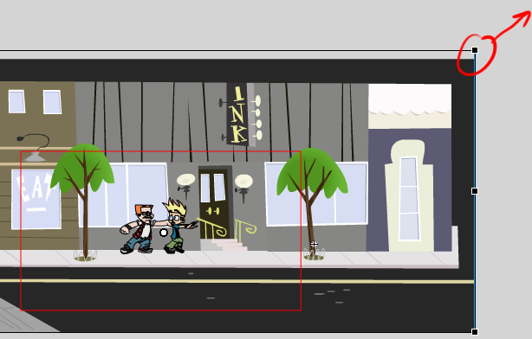

Keeping in mind the red border (signifying the edges of the frame). Make it considerably larger than the original version, about as big as this:

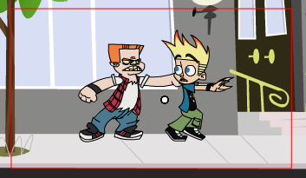

Go to frame 81, key frame it there, now shrink the scene just a bit.
Go up to Modify > Transform > Scale & Rotate... enter: 95% - click OK.

Click and drag to select frames 67 to 78 (your two previous keys) and right click any where in the blue area, choose Classic Tween.
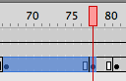

9) Now click keyframe 67, go to your Properties Window and move the Ease: 0 to the left so it eases in to about -80 or -90.

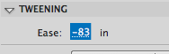

Then click on keyframe 78 and do the same except drag it to the right to 80 or 90 so it eases out.

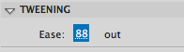

This creates the effect that the camera is starting off slowly to zoom in then bounces back and gradually comes to a stop with just a few frames for a fast zoom in and bounce back.

10) Press Ctrl+Enter to preview the animation. The camera should be starting off gently then maintaining a steady speed while keeping the running character somewhat centered then abruptly changes direction to keep up with the suddenly captured kid, then a brief pause and a zoom-in and bounce.

