Making new Textured Brushes.

First, find the texture you’re looking for.
In Google Images, simply type in ink blots, ink splatter, concrete, concrete texture, concrete cracks, paint strokes, brush strokes, or anything you might be looking for.

Sometimes you have to dig deep to find a nice high resolution one.

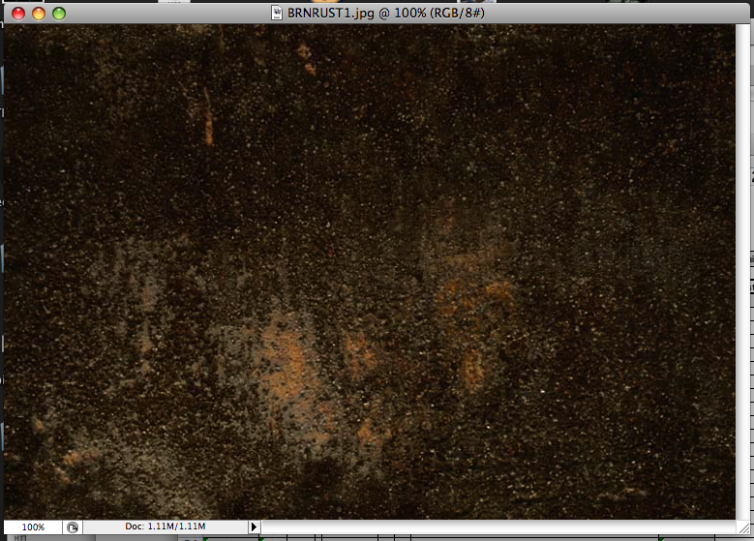

Bring it into Photoshop and select your Magic Wand tool.

Then click on the part of the image you’d like to use. You’ll have to play around with the Tolerance level of the Wand, and experiment with holding down the Shift button as you select other parts of the image to add on to the selection.

Once you’ve grabbed the portions you’d like (the more high contrast and detailed the image is, the more clicking you might have to do), you can then create a new brush by going under Edit > Define Brush Preset…

And BAM you’re done.

Just name your brush ie: texture brush 01

And it will appear amongst your brush collection (at the bottom of the list).

You can save the brush collection you have as well if you’d like.
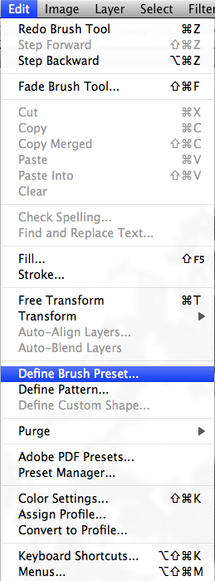
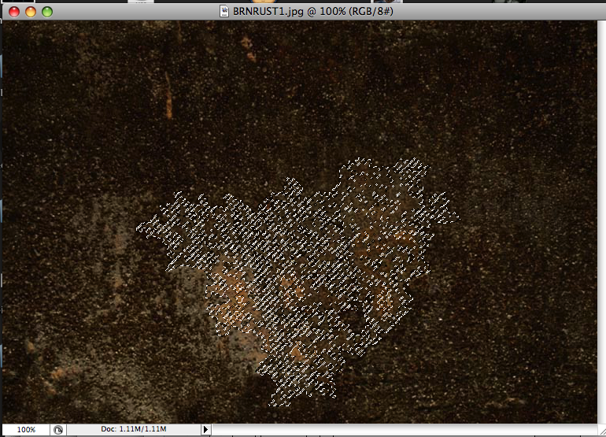

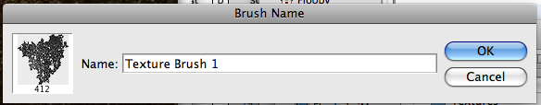

Now you can select your brush, make a new layer over top a transparent BG, and click once to make a stamp, then Save As a PNG and it’s ready to be imported into Flash as an alpha-preserved textured to be masked into your background art.

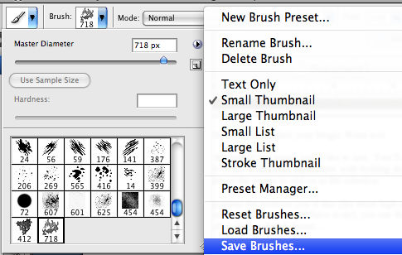
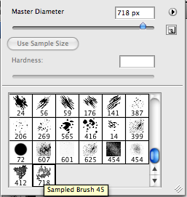

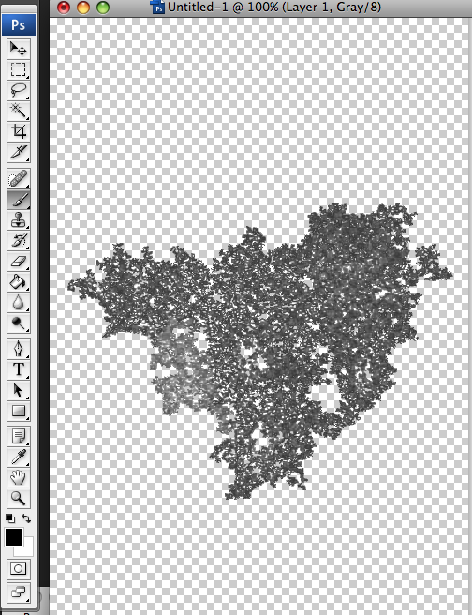

As another option, you can experiment with “feathering”.

Once your area is selected, go to Select > Modify > Feather, pick a low number between 2 and 10 (trial and error), Define Brush Preset and see how the softened edge looks on your brush.

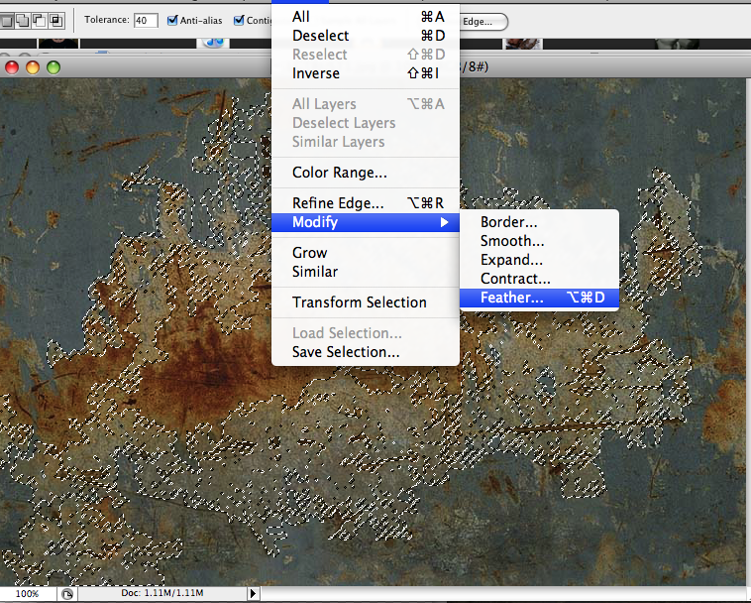

Your textured brush will stamp with a blurry edge, handy for certain effects you may want to achive.
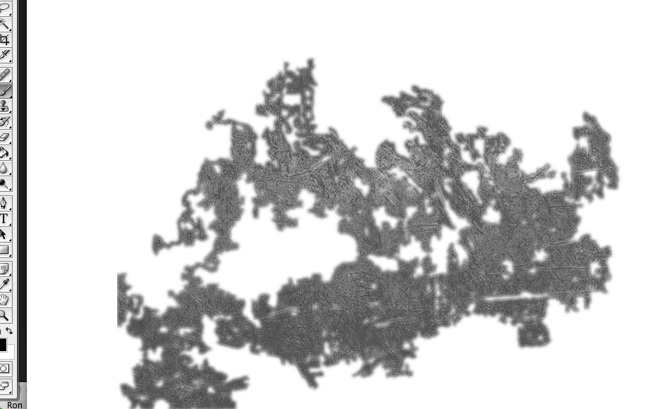

Make sure you have your default white (or colored BG) invisible when saving as a PNG so the alpha is preserved in the export.

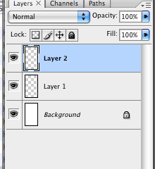

As another option, you can warp and skew your stamped texture brush to fit the background it will be texturing with these simple tools…

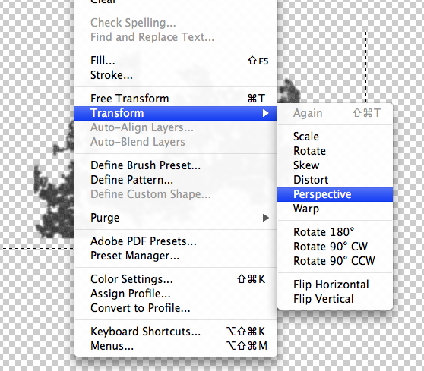

Select the texture, go to Edit > Transform > and pick which feature to use to distort the texture, watch out because the lower the resolution of your file and the more distorting you do, the more blurry the image may become.
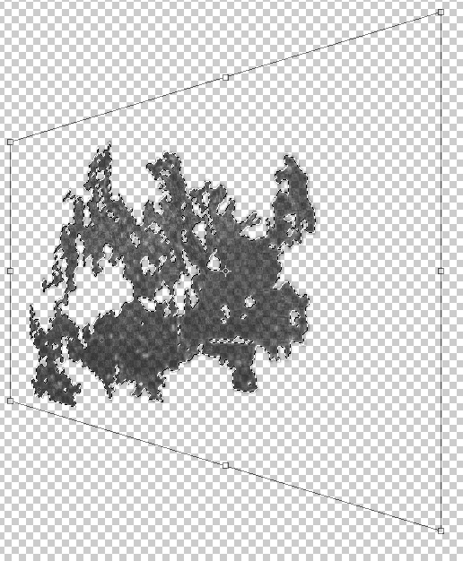

The more time you spend carefully selecting bits and pieces of the image (whether it’s from a photo or an illustration you’ve made) the more detailed your brush could be.

Also if you are sampling from a photo, the higher resolution the image is the larger and sharper the custom brush will turn out to be.

